National Chinese Sahaja Yoga Seminar Lianhuashan Guangzhou, China

Words can’t describe the joy we all felt during this momentous occasion of our first national Sahaja Yoga seminar in China this past weekend - July 30 to August 1. Exactly 108 Yogis attended with seekers from provinces all over China, with support from established yogis from Hong Kong, Taiwan and Singapore. It is exactly ten years since Shri Mataji visited China at the World Women’s conference in Beijing in September1995. Since that time China has been progressing slowly because of the crackdown on Faulong Gung and other religious organizations. Shri Mataji said that we should keep a low profile and simply give realization which we have been doing. Amazingly the medium to give realization has been the Chinese website. There are thousands of hits per day. We know that many people have been able to get realization off this website and we have had many emails from people interested to practice. Our problem has been to support these seekers remotely and it is something we are putting attention on at the moment to create a virtual learning environment where they can develop their understanding and practice of Sahaja Yoga. Fortunately the really keen seekers have been able to travel to the collective centres in Beijing, Shanghai, Guangzhou or Shenzhen and occasionally to Hong Kong. This has given us a foundation of yogis and they have been actively giving realization to family and friends. The openness and sincerity of the seekers in China is so refreshing. They just take to it without the usual intellectual baggage that so many seekers in the west have. Shri Mataji said that when it works out in China it will spread like wild fire and we had better be prepared. From what we have seen this weekend we can see what she meant. She has done the preparation by coming here in 1995. Her face was shown on national TV after She was interviewed and it was the last image of the news program so tens of millions would have seen Her smiling face.

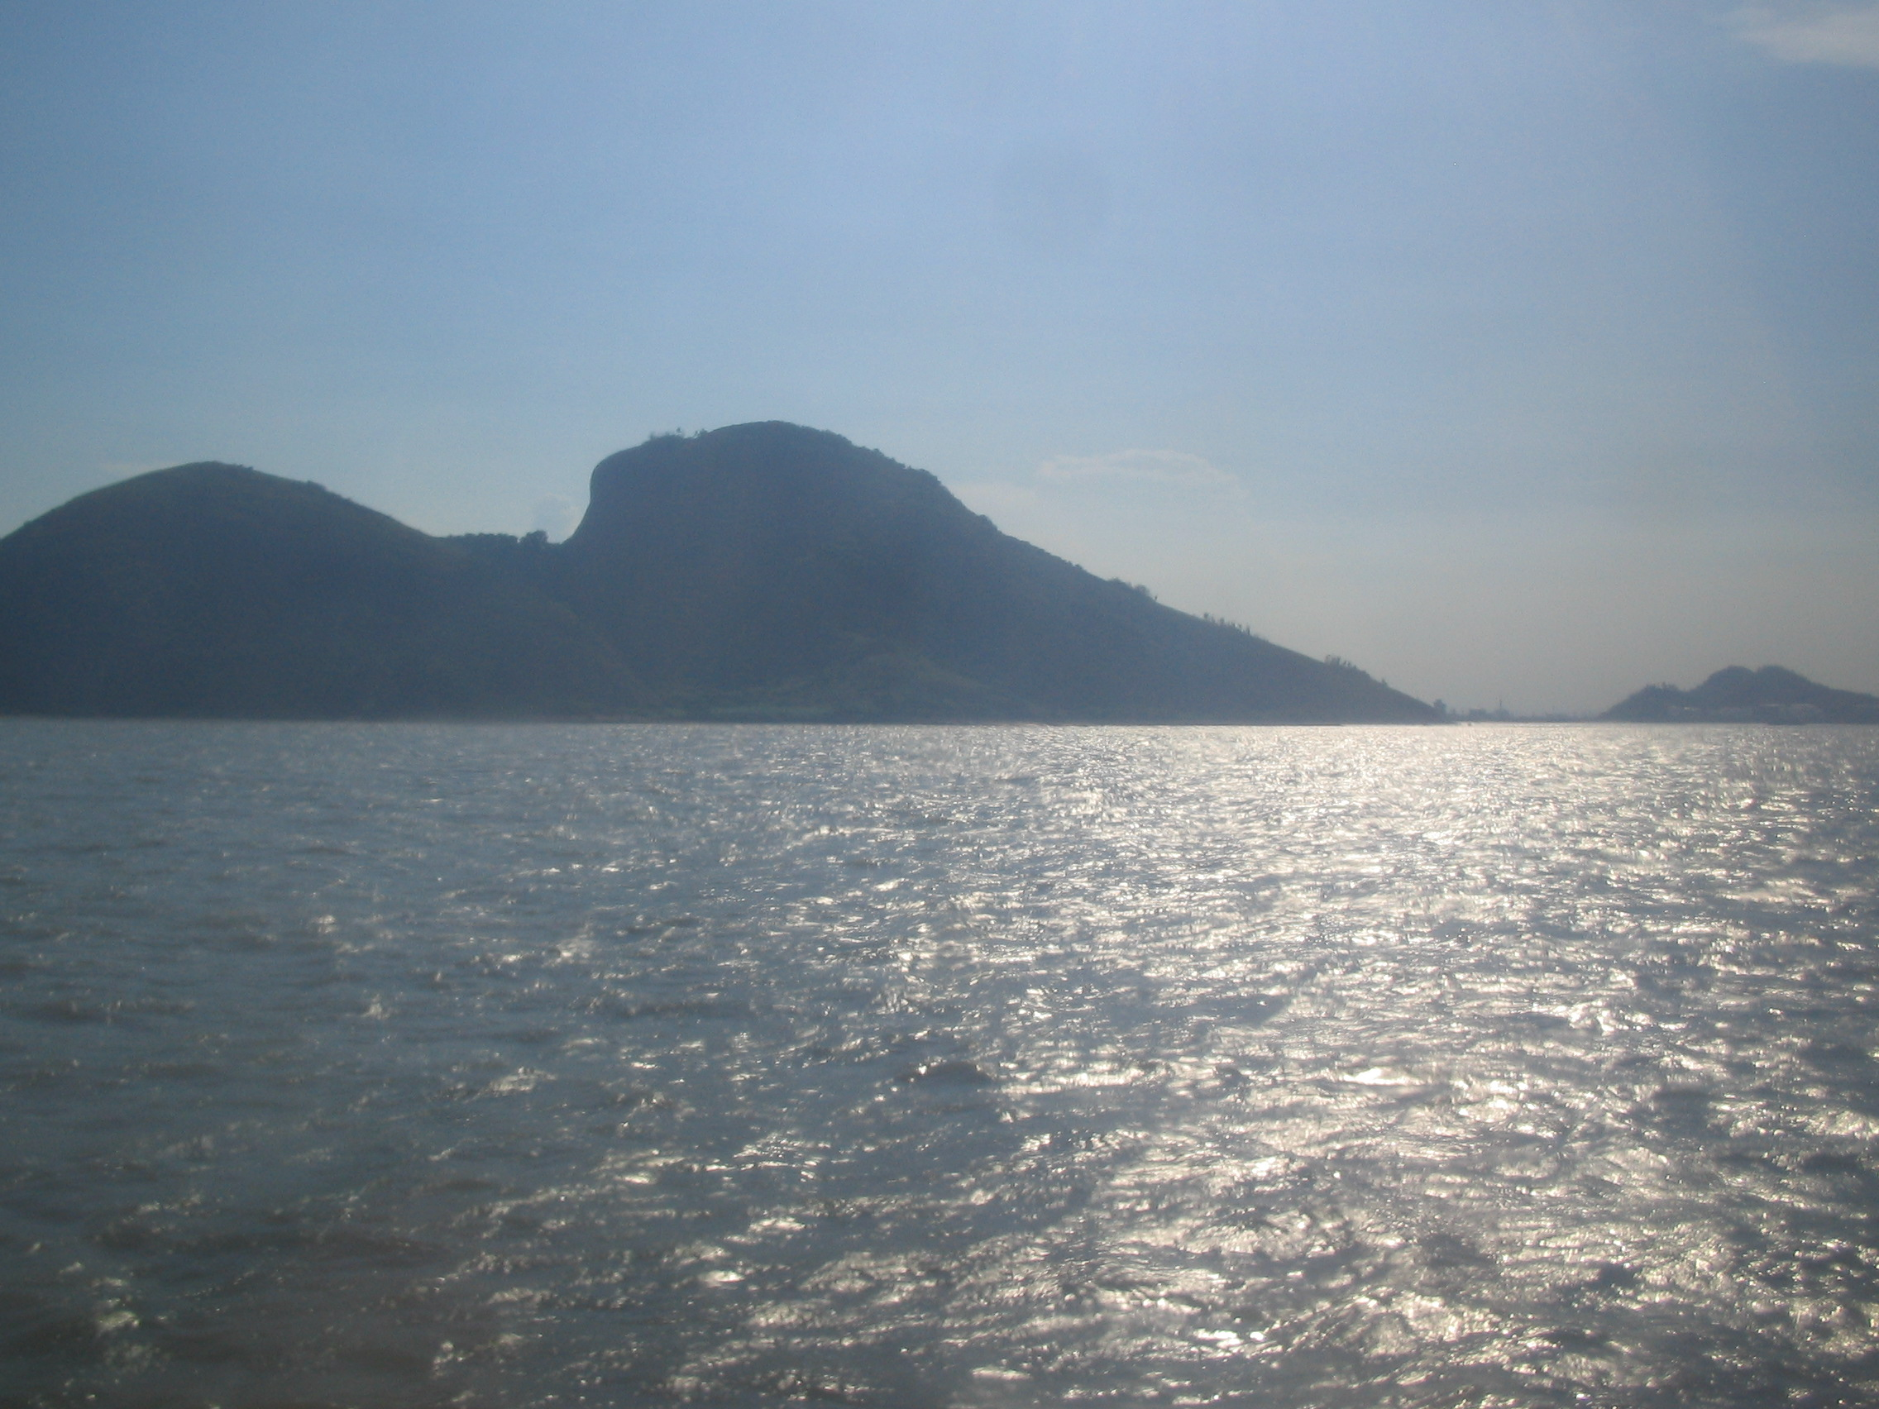

An Island on The Pearl River resembling an elephant. 20 mins by boat from Lianhuashan

Lianhuashan is located on the Pearl River Delta about 130 km form HK about 2 hours by high speed ferry. We booked a Government-run vacation village surrounded by gardens and lotus ponds full of flowering lotuses.

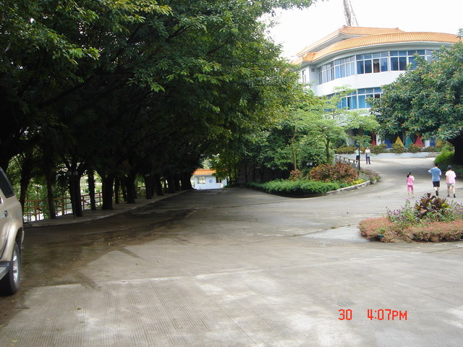

Because it is Government run it is very affordable for people in China and the manager made a special effort to welcome us and make our stay very comfortable. Normally this time of year the weather is very hot and humid but intermittent rain kept the temperature at a comfortable level.
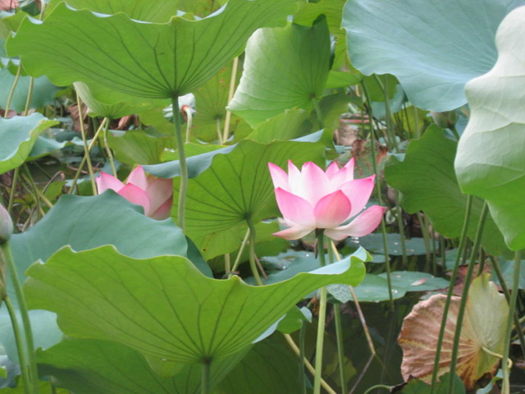

An advance party from Hong Kong arrived there on Friday afternoon and they were joined by a group coming from Beijing and provinces other than Guandong . They enjoyed a collective meditation, indoor havan, Alla Huakbar and bajhans. The following day the majority of people, mainly from Guangzhou and nearby Shenzhen, plus HK and Taiwan, arrived and we continued with teaching the mantras. Some people had only had realization for 15 days so they were literally thrown into the deep end. Everyone could feel the power of the mantras and how they cleared the chakras. They were like small children who have discovered something wonderful and you could feel the excitement rising in them with each new thing they leant. Some were studiously taking notes so they could relay this knowledge to their group back in another province. One man, who had a very pained expression on his face, asked if Sahaja Yoga could help his physical and mental problems. We explained that it could help solve many problems both mental and physical but he remained skeptical. I kept an eye on him and by the end of the weekend he completely transformed and was smiling and joyful. I asked him how he now felt and he said he was feeling so good and he knew Sahaja Yoga was what he had been seeking for so many years. He said words couldn’t describe the joy he felt especially when we sang bajhans. They all responded to the music and clapped and danced. After most sessions we would have a round of Bajhans so the mood was kept very light and joyful. We even had a newly wed couple who celebrated their honeymoon with all the yogis at the seminar!

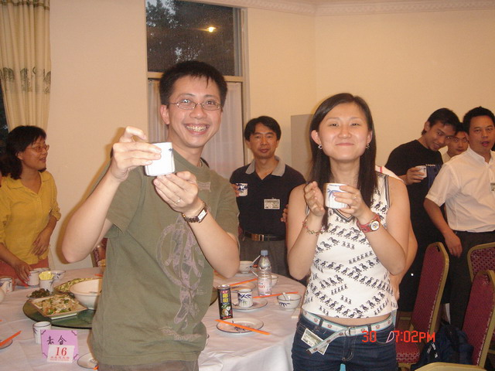

Jenny and Jackson were married a day before they came to the seminar so everyone celebrated this happy union

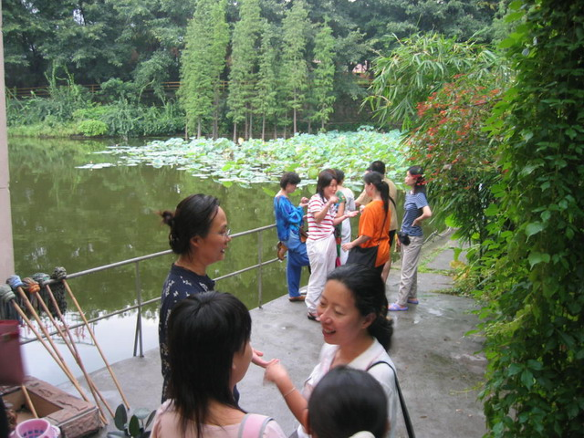

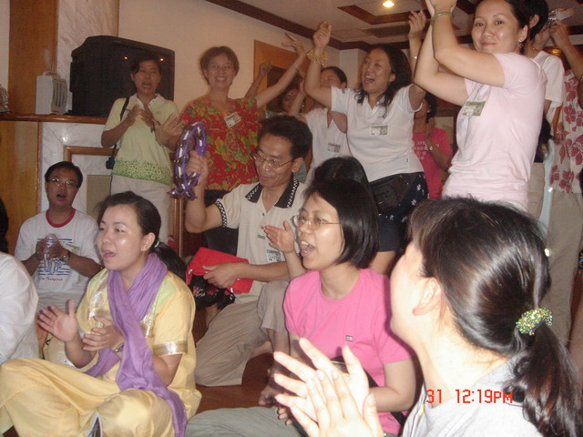

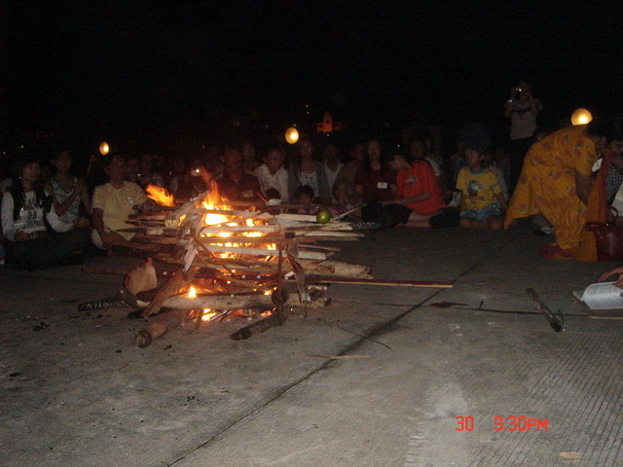

To add to the weekend the nabhai was completely satisfied with traditional Cantonese food. The Chinese have such a wide variety of cuisine and for a government run institution the quality was extremely high. They use some organic vegetables grown from their own garden and no MSG. We tried to mix up the tables twelve in all so everyone had a chance to exchange with someone from another part of China. During meal times there was such a joyful sharing of experiences.

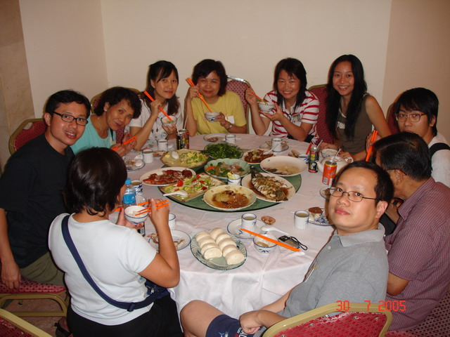
The majority of the participants were Chinese but we also had an Australian, three British, one German, two Indians and a Russian adding to the interest of the local Chinese who aren’t use to interacting with many foreigners. A little English went a long way as we all felt the same higher level of awareness so words were not so important. Many of the participants I spoke to all felt compelled to go back and give realization and establish a collective. Two ladies had come all the way from Kunming in Western China after getting realization from the website. They were so grateful for us to host the seminar and they are eager to spread the love they both felt. They have a collective of four people but the other two were unable to make it. Now with what they’ve learnt they will be able to share the knowledge and give more people realization. A man from Tainjin a city on the coast around one hour from Beijing traveled a long way to learn more about Sahaja Yoga. He had been introduced by a friend. Around ten came from Beijing where the group has been going for a number of years now. In Shanghai Thelma Patmore has established a small collective and is running programs from a friend’s nail bar. Shamilla and Julian Kingsbury brought their baby boy Ping Ping and a German lady and Purnum so altogether 5 and a half people.

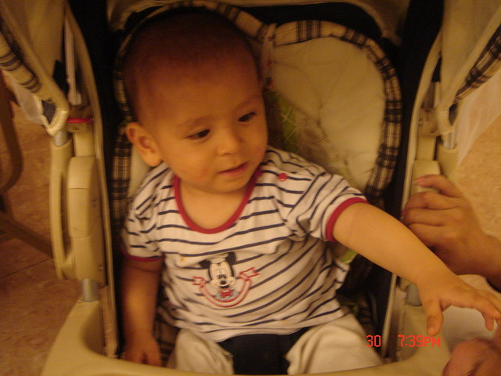

On Saturday it had been raining most of the day so we though that we would be unable to d a havan but the elements were in tune with our desires. After dinner the clouds cleared and a distinctive bandhan around the havan venue appeared where you could even see the stars. The havan was significant as we needed to clear the back agnya of the whole of China. The majority of the Chinese attending from China had never experienced a havan before and didn’t know what to expect. The manager of the resort insisted that the staff attended to make sure that the fire wouldn’t get out of control. Fortunately we had a large concrete quadrangle for the havan venue and lots of wood even though it was a little wet. We built up a large fire and primed it with camphor so it would certainly burn. The Agni Deveta matra was sung and fire surged and was quickly alight. Purnam, a lady originally from Delhi whose husband is based in China read the 108 names of Mahakali. The wood occasionally sent an explosion of hot ash. The wind whirled around and we could feel the heat. After every Om Swaha you could feel the fire sucking out the heaviness on the left side. It was such a powerful experience even for a seasoned yogi. After we finished reading the mantras there was a profound feeling of peace. Everyone was silent and we all sat in meditation for a long time, still and silent starining into the glowing embers.

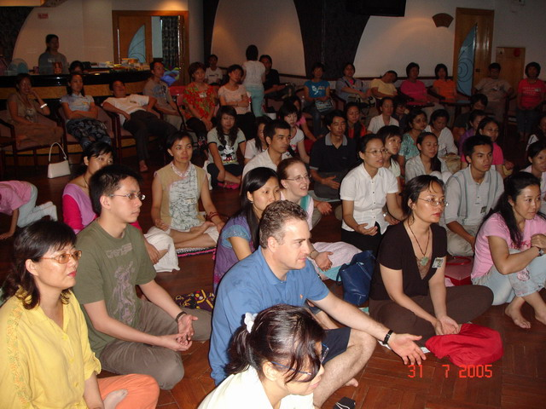
At the Sunday morning meditation the vibrations had completely changed after the havan. The underlying catches that were floating around had gone. We did some simple clearing of the left and right channels and then enjoyed a very deep and silent meditation. No one wanted to move. After breakfast we watched Shri Mataji talk and continued with the program. We had a little extra time to let the food settle and then we continued with Shri Mataji’s puja talk. The tape was subtitled in Chinese so everyone could understand. I watched the faces of our new Chinese brothers and sisters glowing with the knowledge that they had found their spiritual mother. They are all deep seekers of truth and I’m sure that they will carry this truth back to their home provinces. It was quite amazing that there were ten cities of China represented and every province except for inner Mongolia and Tibet. How the divine arranges everything for us.
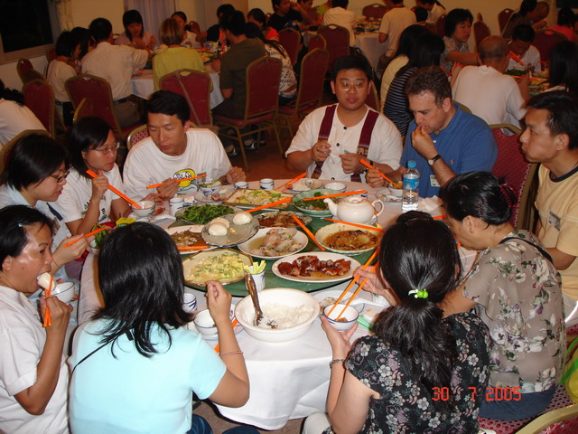

We enjoyed another banquet style lunch with so many dishes and after lunch we all assembled for a collective photograph. We had a lot of fun and everyone wanted a group photo of their collective so it took some time to finish. We then had a session of collective sharing and many of the new yogis came forward to talk about their experiences. One man only got his realization 15 days before off the internet. He had been very keen to learn more and had been seeking for many years. He was amazed by what he found and said that everything that was promised in what he had read was delivered in the two days of the seminar. He had felt absolute joy and could not express how he felt. Another young man took the mike but could not speak but tears of joy rolled down his face. He didn’t need to speak as we all felt the same! Another lady who had traveled from Kunming in Western China said that there were 4 yogis practicing Sahaja yoga there and all had found it through the Chinese website. One of the HK yogis, Heman had traveled there on a business trip and had helped them learn more about meditation and SY. The seminar had been a wonderful boost and they felt confident to be able to spread SY in their home town. It was such a joy to listen to these new yogis how had been catapulted into the realm of divinity. They were all bliss casualties.
We were then given presentation on the relationship of Shaja Yoga and ancient Chinese philosophy. So we touched the roots and saw how this ancient culture had secret knowledge from the adi guru. This was followed by more bajahans and we were all up and dancing.

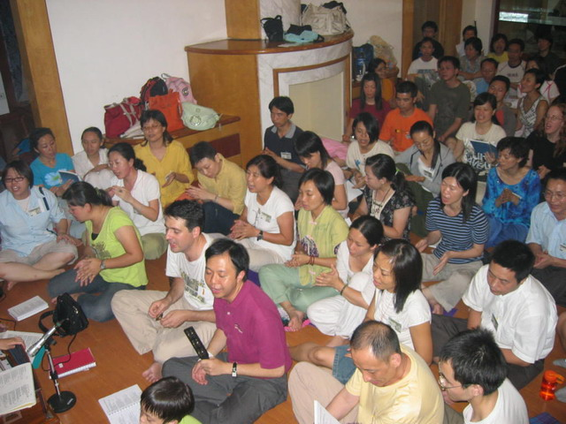
Sunday evening we enjoyed head rubs and we had a lot of joyous fun and exchange of vibrations. Many people had stayed on for a half day on Monday so we managed to teach them about puja, elements, madka and shoebeating. One lady had a very strong experience shoe beating, She had been feeling dizzy and after shoe beating it all went away and she felt such strong cool. After lunch many had to leave and it was hard to go. Many had tears in their eyes as we waved goodbye. Such a fulfilling and joyous weekend and I’m sure we look back at this joyous seminar as turning point in the establishment of Sahaja Yoga in China.

Alex

p.s. To view more photos of the event, click to www.kundalini.org.hk

